**Exercise No 8: TraceRoute, ping, ifconfig, ipconfig, netstat**

**Aim:**

Using TraceRoute, ping, ifconfig(LINUX), ipconfig(WINDOWS), and netstat Command.

Procedure:

Step 1: open windows command prompt and Type tracert command and type tracert [www.saveetha.com](http://www.saveetha.com/) -> “Enter”

Step 2: Type ping command and type IP Address press “Enter”

Step 3: Type ifconfig command

Step 4: Type netstat command

**Output:**

Tracer:

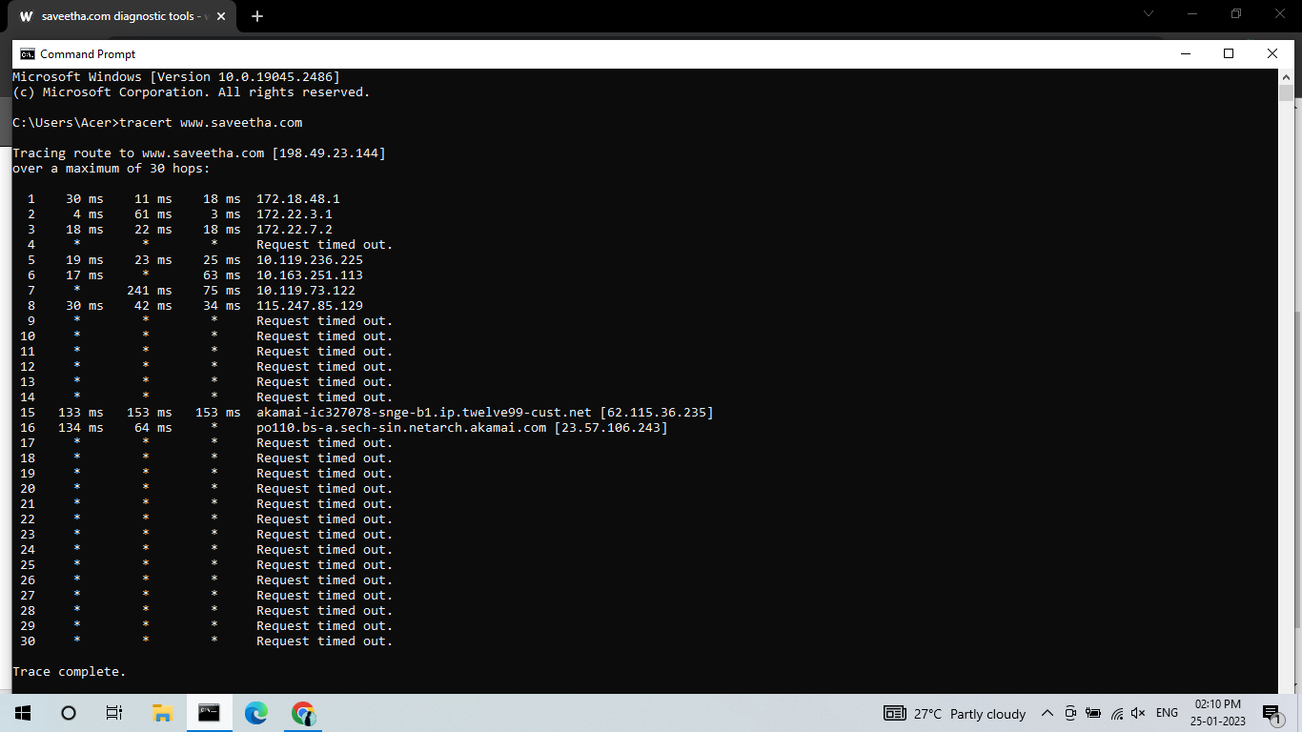

Ping:

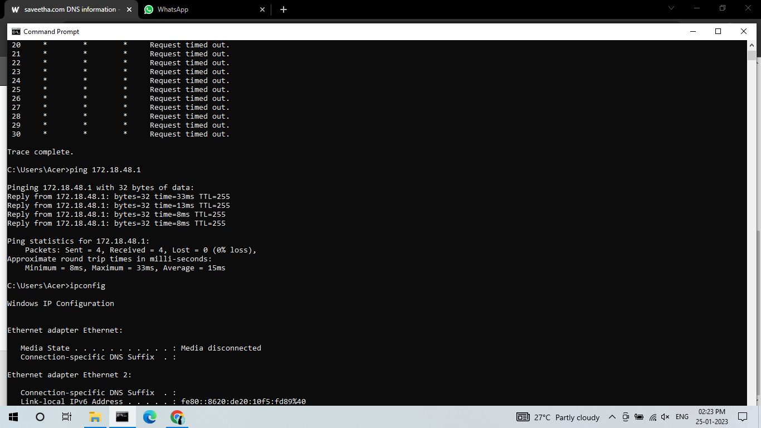

IP config:

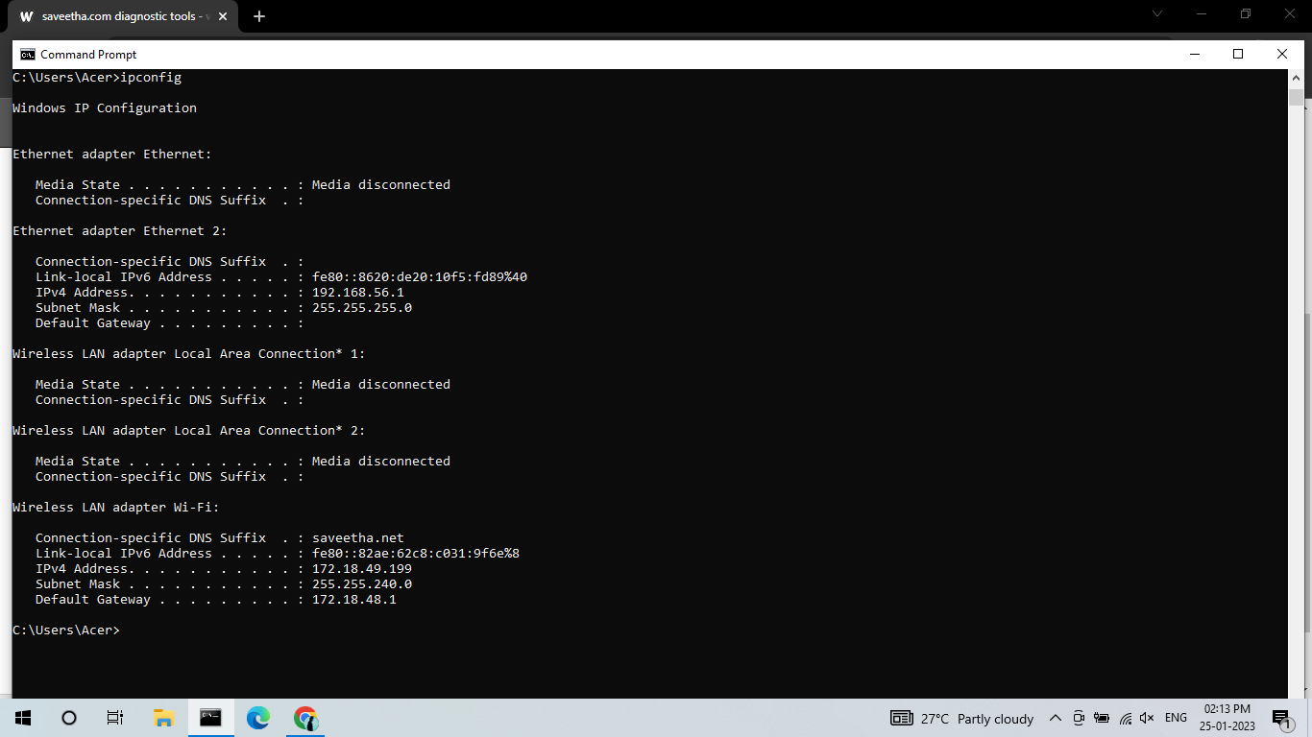

Netsat Command:

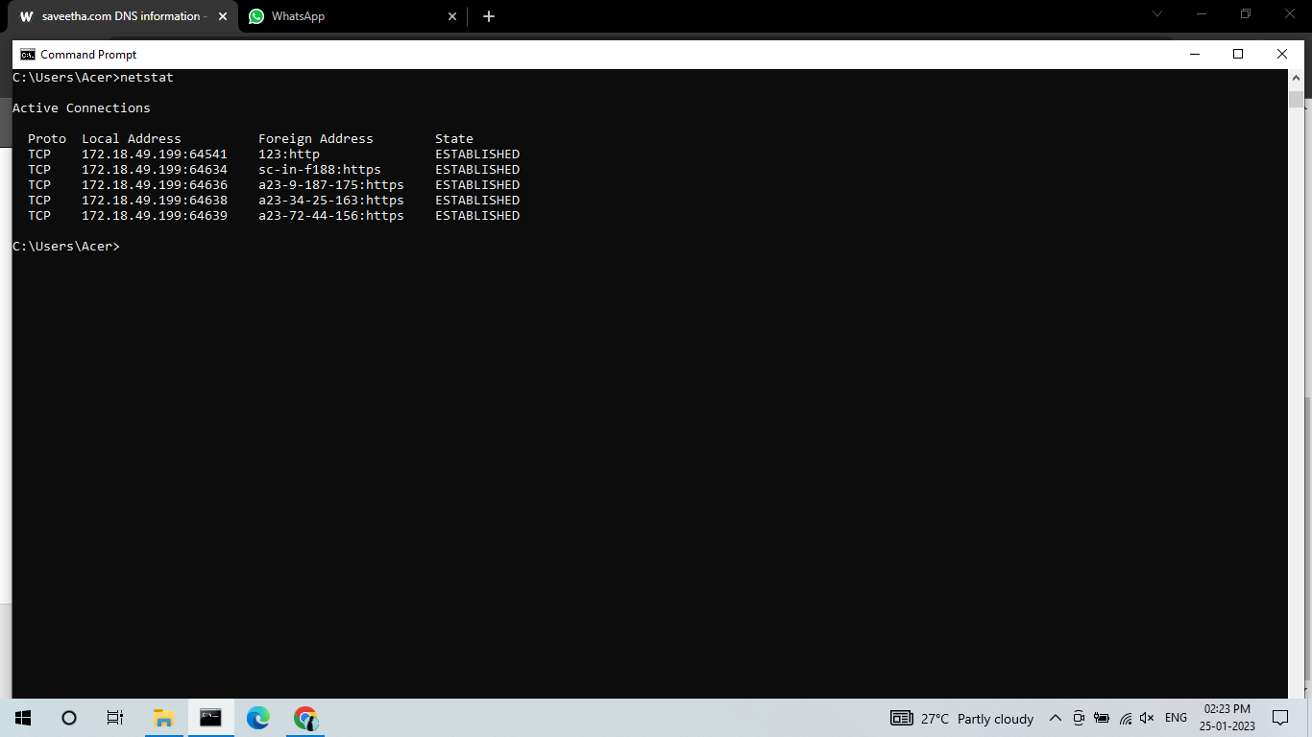

**Result:**

Thus, the program has been implemented successfully.